## iPerf3

The iperf.exe application can be downloaded from the following link: <https://iperf.fr/iperf-download.php>

1. Enter the SSID and passphrase.
2. To automatically load the signed firmware image for iPerf3 application, select the iPerf3 tab
3. It is recommended to click on PROG Flash to start Talaria TWO as a Server.

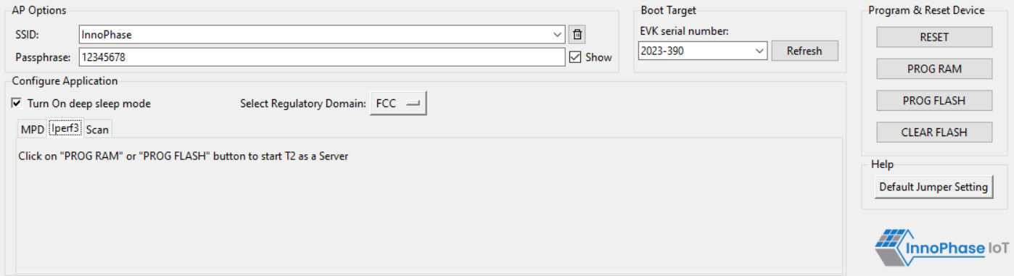

Figure 17: Selecting iPerf3

**Note**:

1. In case the PROG RAM option does not load the application, click on PROG FLASH.
2. Work around for the above limitation is to click Reset before clicking on PROG RAM again.
3. Work around for error with CLEAR Flash option: Click Reset before clicking on CLEAR Flash again.